**Working with layout and Responsive Web Design**

**Objectives**

* Web layout HTML5
* Create your own responsive design

**Exercise 1** **(2 marks)**

* Develop website display page index.html as follows

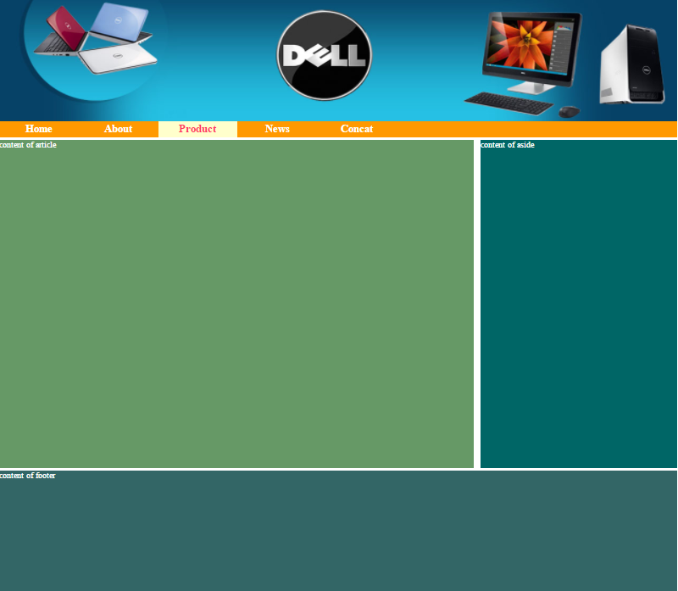

Guide:

* Code HTML

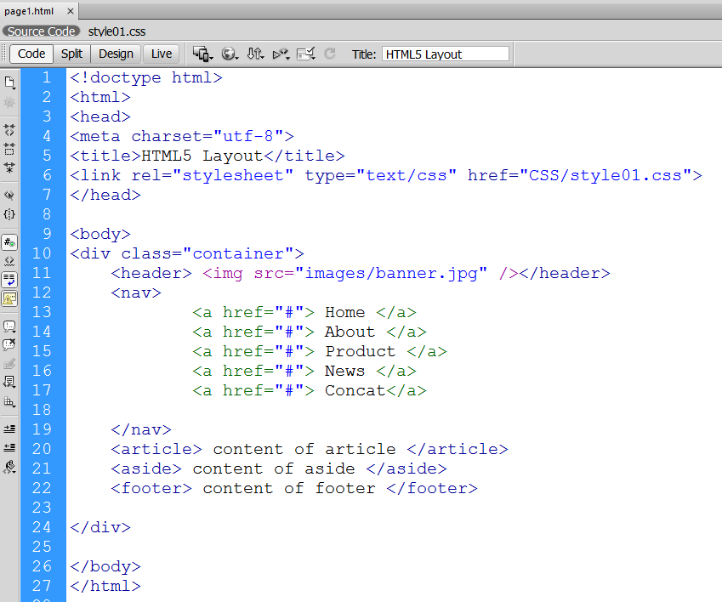

* **Code CSS**

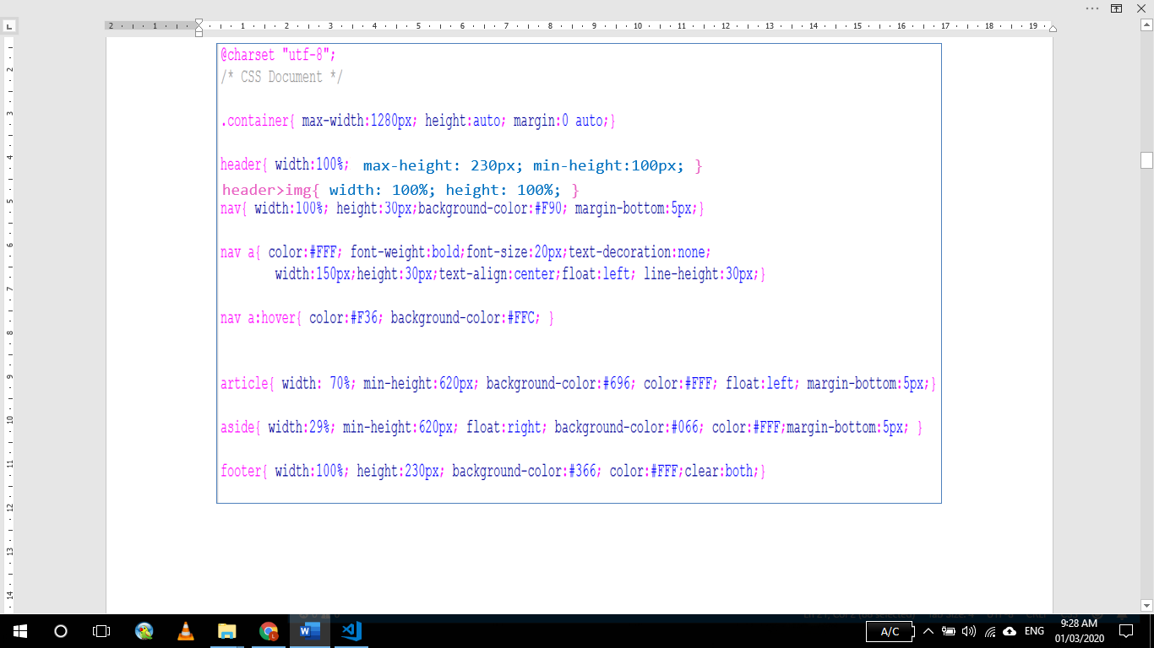

**Exercise 2 (2 marks)**

* Develop continue website display page index.html as follows

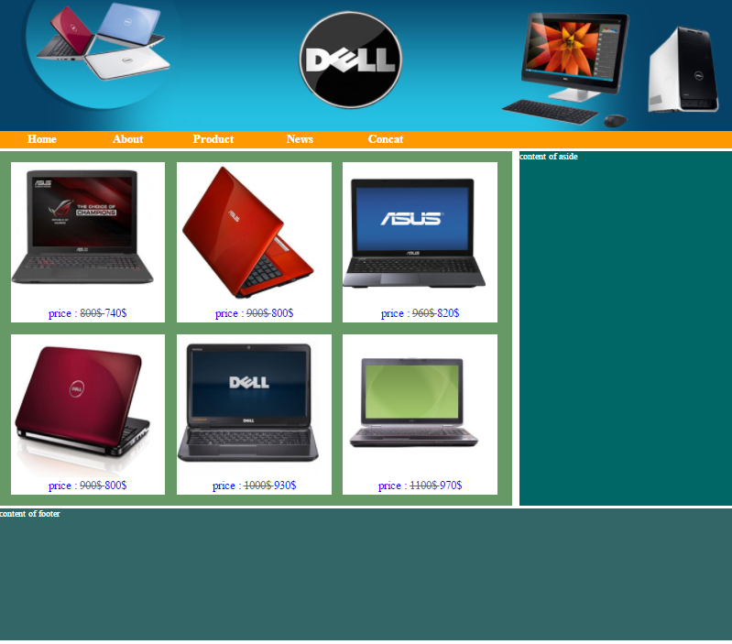

Guide:

Using tags : div, h1,p, img

Guide:

* Code HTML

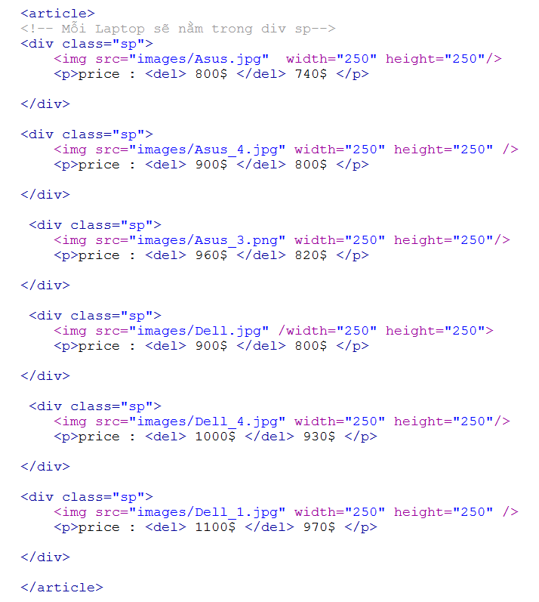

* **Code CSS**

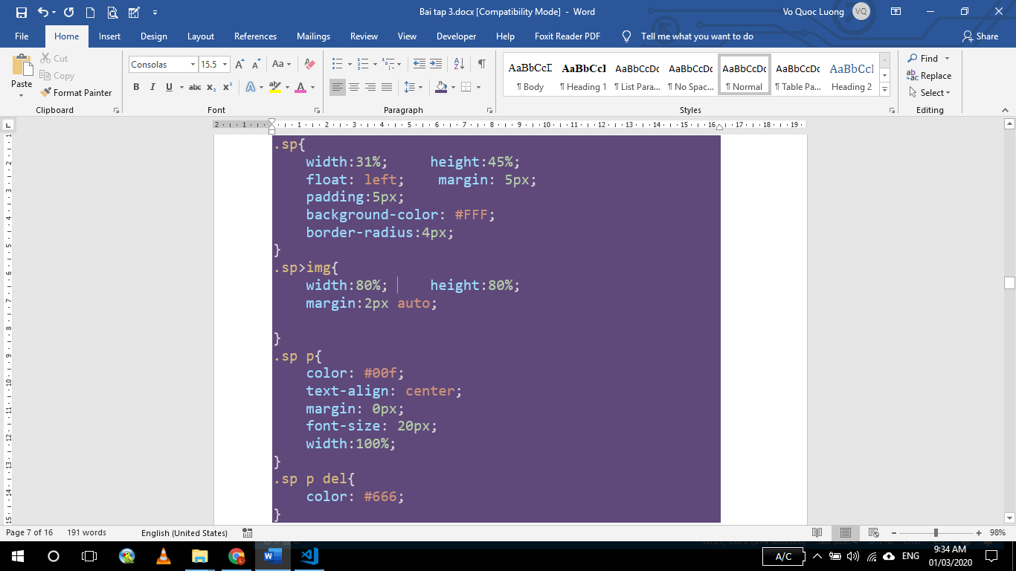

**Exercise 3 (2 marks)**

* Develop website display page index.html as follows

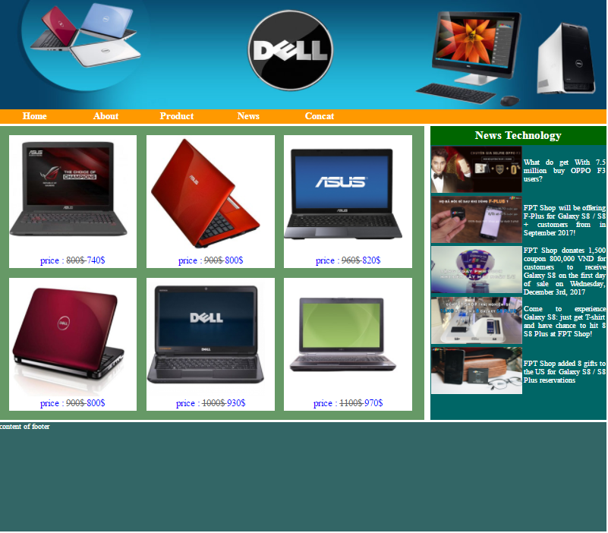

Guide:

* Code HTML

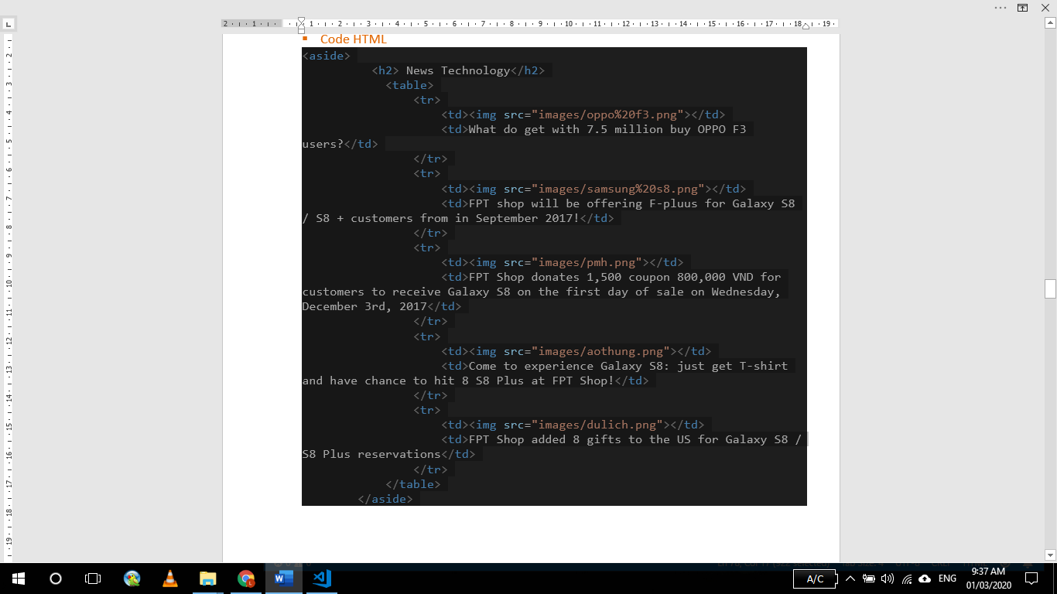

* **Code CSS**



**Exercise 4 (2 marks)**

* Develop continue website display page index.html as follows

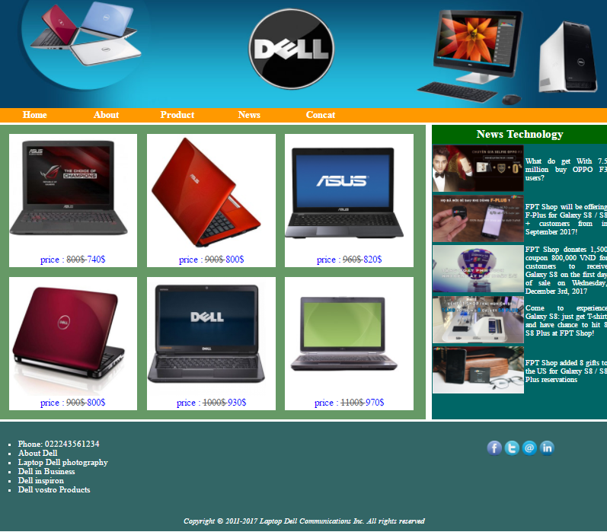

Guide:

Using tags : div, ul, li

Guide:

* Code HTML

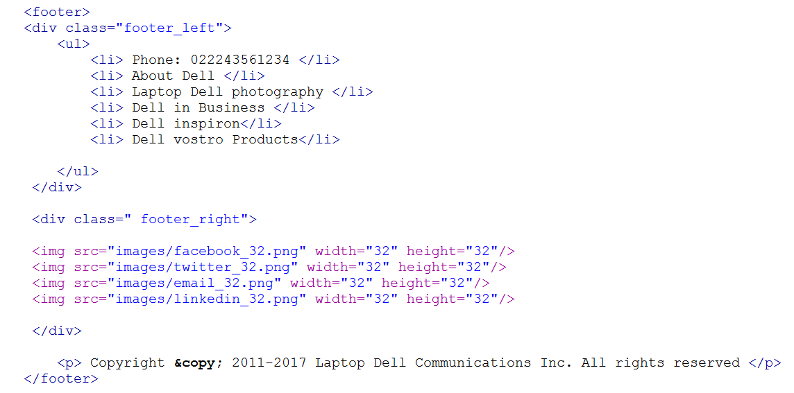

* **Code CSS**

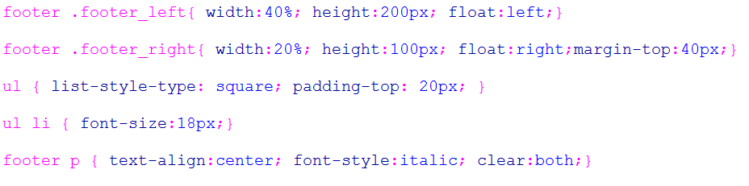

**Exercise 5 (2 marks)**

* Develop website display news .html as follows

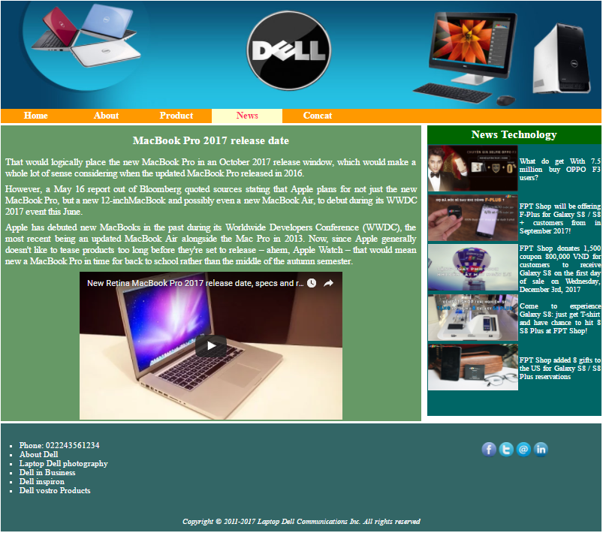

Guide:

* Code HTML

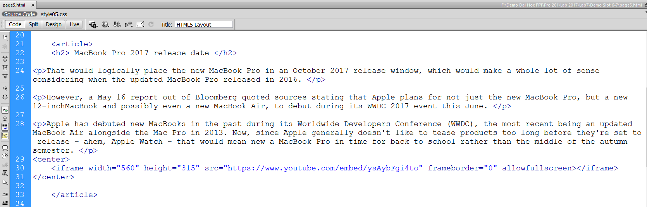

* **Code CSS**

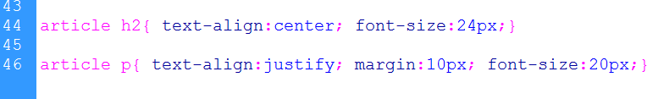

**Exercise 6 (2 marks)**

* Develop continue website display page concat.html as follows

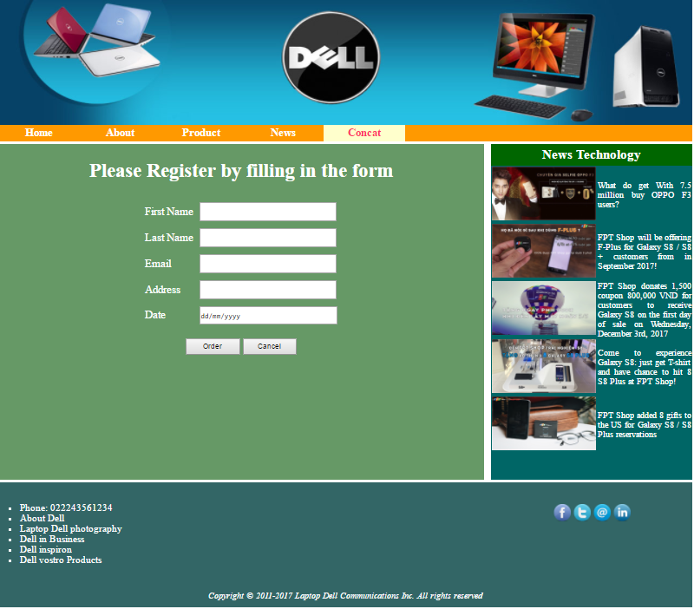

Guide:

Using tags : Table, form, colpan,

* **Code HTML**

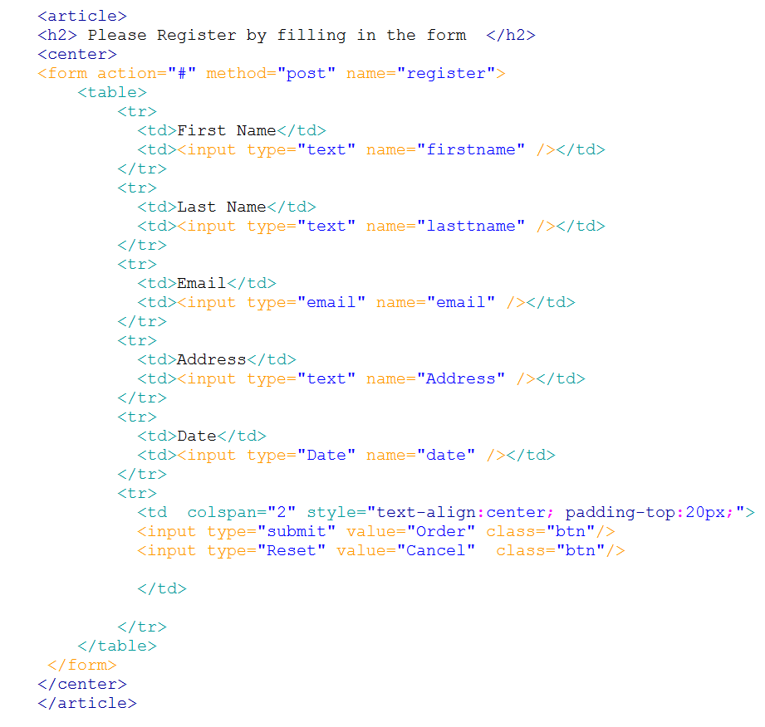

* **Code CSS**

